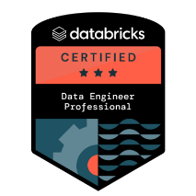
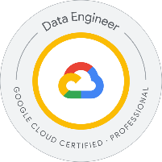
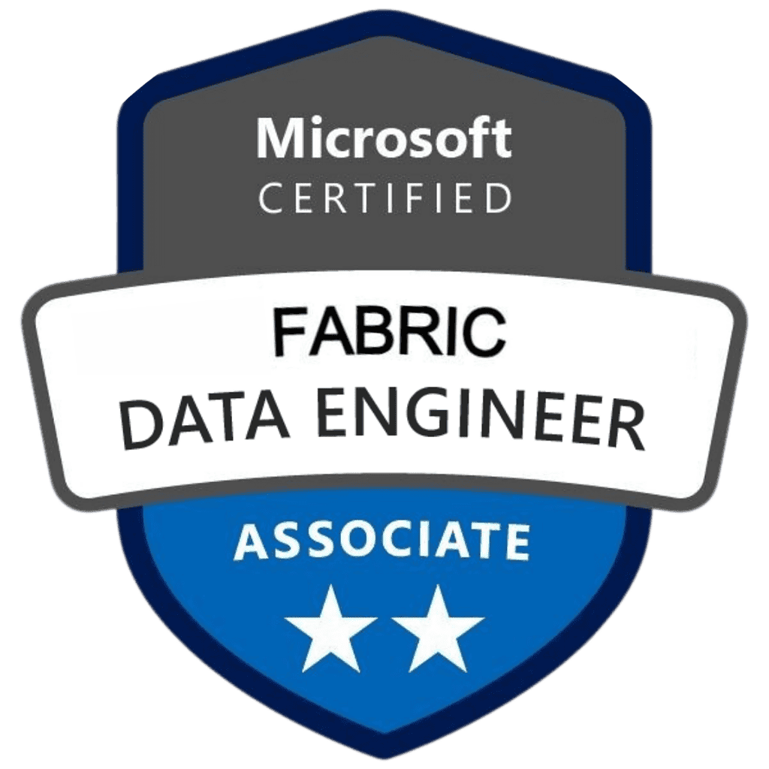
BHANU PRAKASH
GEN AI Engineer
Email: bhanuprakashreddym09@gmail.com || Ph No: +1 203-805-8519

SUMMARY:
- Overall 11+ years of experience delivering data engineering and Generative AI solutions, specializing in healthcare, banking, finance, and HR domains with end-to-end AI pipeline design, deployment, and governance.
- Built retrieval-augmented generation (RAG) pipelines using Azure OpenAI, LangChain, Pinecone, and Weaviate, enabling HIPAA-compliant contextual querying of clinical notes, insurance claims, and regulatory filings.
- Designed fraud detection workflows with AWS Bedrock, Kafka, and Spark Structured Streaming, identifying suspicious credit card transactions and reducing compliance risks through real-time anomaly monitoring.
- Developed claims summarization models using Azure OpenAI and Databricks Delta Lake, automating medical claim adjudication and accelerating healthcare reimbursement cycles.
- Created financial compliance Q&A bots with LangChain and Hugging Face Transformers, enabling auditors to query regulatory data with contextual, evidence-backed AI responses.
- Engineered vector embeddings and semantic search systems with Pinecone and Bedrock embeddings, powering intelligent retrieval for regulatory and financial documentation.
- Automated ETL pipelines using Databricks, ADF, and Python, preparing structured and unstructured datasets for AI/ML model consumption across enterprise data lakes.
- Implemented text classification pipelines with scikit-learn and Hugging Face, categorizing clinical documents, payroll reports, and compliance filings into standardized taxonomies.
- Built employee self-service chatbots using Dialogflow and Azure Bot Services, automating payroll queries, HR benefits assistance, and attendance inquiries, improving workforce productivity.
- Designed synthetic data generation frameworks in Databricks and Python, creating safe, de-identified healthcare and financial datasets for AI model training.
- Created financial risk scoring pipelines by integrating Equifax and TransUnion APIs into LLM workflows, improving underwriting and credit decision-making processes.
- Delivered real-time monitoring dashboards in Tableau and Power BI, integrating GenAI-powered fraud detection and compliance insights for business stakeholders.
- Fine-tuned LLMs with domain-specific datasets, ensuring higher accuracy in healthcare claims processing, compliance documentation parsing, and financial risk analysis.
- Implemented role-based access policies (RBAC) within AI pipelines, ensuring PHI and financial data security under HIPAA, PCI DSS, and SOX regulations.
- Developed document summarization pipelines with Transformers and LangChain, condensing lengthy financial reports and clinical transcripts into consumable executive summaries.
- Built predictive analytics models in Python, R, and Databricks ML, supporting risk management, workforce planning, and patient care optimization.
- Established data governance and lineage frameworks with Unity Catalog and Apache Atlas, providing transparent audit trails for regulatory compliance.
- Automated OCR-driven ingestion workflows using Azure Cognitive Services, digitizing paper-based claims, tax forms, and compliance documents into AI-ready formats.
- Implemented CI/CD pipelines for GenAI models using Terraform, GitHub Actions, and Jenkins, streamlining deployments and reducing operational risks.
- Conducted explainability audits with MLflow, SHAP, and Weights & Biases, ensuring transparent AI outcomes for healthcare and banking stakeholders.
- Integrated FHIR and HL7 APIs into GenAI workflows, ensuring interoperability with electronic health record systems and improving clinical data availability.
- Developed market sentiment analysis tools using NLTK, SpaCy, and Hugging Face, classifying news and analyst reports to assist investment advisors.
- Migrated legacy reporting workflows into cloud-based AI ecosystems (Azure, AWS, GCP), improving scalability and reducing infrastructure costs.
- Designed LangChain-powered contract parsing solutions, extracting key clauses from insurance and financial contracts, reducing manual legal review effort.
- Partnered with compliance teams to enforce AI governance best practices, ensuring all GenAI use cases aligned with ethical AI and regulatory guidelines.
- Built recommendation engines using Snowflake, Python ML, and Bedrock embeddings, enabling hyper-personalized cross-sell strategies in financial services.
- Designed semantic Q&A pipelines for healthcare claims adjusters, using Azure OpenAI and Pinecone to provide contextual claim resolution support.
- Engineered batch and streaming data pipelines with Databricks, Spark, and Kafka, supporting both real-time anomaly detection and large-scale batch AI training.
- Created compliance-ready reporting pipelines that automated generation of OCC, SEC, and CMS reports, improving regulatory inspection preparedness.
- Drove enterprise-wide adoption of Generative AI by delivering roadmaps, training, and POCs, scaling LLM-driven automation across claims, fraud, HR, compliance, and financial advisory domains.

TECHNICAL SKILLS:
Category | Skills
Programming Languages | Python, R, SQL, PySpark, Spark SQL, Scala, Java, Go, Shell Scripting, T-SQL, JavaScript, Django, Flask
Machine Learning & NLP | scikit-learn, XGBoost, LightGBM, TensorFlow, PyTorch, spaCy, Transformers (BERT, GPT), Hugging Face, MLflow, SHAP
LLM & GenAI Technologies | LangChain, OpenAI API, ChatGPT, LoRA, QLoRA, PEFT, RAG, FAISS, Prompt Engineering, BERT, GPT, Agentic Reasoning
Cloud Platforms | AWS (S3, SageMaker, Glue, Redshift, Lambda, EMR, Step Functions), Azure (ADF, Synapse, Event Hub, ML Studio, DevOps), GCP (BigQuery, Vertex AI)
Data Engineering & ETL | Apache Spark, Apache Kafka, Apache Flink, Apache NiFi, AWS Glue, Azure Data Factory, Talend, Airflow, Databricks
Data Warehousing | Snowflake, Amazon Redshift, BigQuery, Azure Synapse Analytics, Teradata, SQL Server, Oracle, PostgreSQL, MySQL
Streaming & Real-Time Data | Apache Kafka, Azure Event Hub, AWS Kinesis, NiFi, Event-driven pipelines
Visualization & BI | Power BI, Tableau, Databricks SQL Analytics, QuickSight, Matplotlib, Seaborn
Model Monitoring & MLOps | MLflow, Prometheus, Grafana, Azure ML Registry, Confluence, Jira, Model Drift Detection, Bias Audits
DevOps & CI/CD | Git, GitHub, Bitbucket, Jenkins, Azure DevOps, Terraform, Docker, Kubernetes, YAML, GitHub Actions

CERTIFICATIONS:
- Microsoft Certified: Azure Data Engineer Associate (DP-203)
- Google Cloud Professional Data Engineer
- AWS Certified Data Analytics – Specialty
- Snowflake SnowPro Core Certification
- Databricks Certified Data Engineer Professional

PROFESSIONAL EXPERIENCE:
Client: United Health Group, CA November2022 – Present
Role: Gen AI Engineer
Responsibilities:

- Designed and deployed HIPAA-compliant RAG pipelines using Azure OpenAI, LangChain, and Pinecone, enabling clinicians to query unstructured patient records and claims data with domain-specific, evidence-backed contextual responses.
- Built claims summarization models with Azure OpenAI GPT APIs and Databricks Delta Lake, reducing manual review efforts and accelerating insurance claim adjudication workflows.
- Engineered clinical note analysis pipelines using LangChain and Azure Cognitive Services, extracting diagnosis codes, treatments, and medications to support care teams with structured EHR insights.
- Developed patient engagement chatbots leveraging Azure OpenAI and LangChain, automating responses for appointment scheduling, benefits inquiries, and prescription renewals while maintaining HIPAA data privacy standards.
- Implemented vector embeddings and semantic search using Pinecone and Weaviate, allowing doctors to retrieve patient history across distributed EHR systems with contextual accuracy.
- Built real-time healthcare analytics dashboards in Power BI and Databricks SQL, integrating AI-driven claims and patient insights into clinical workflows.
- Automated ETL pipelines with Azure Data Factory and Databricks notebooks, preparing structured/unstructured healthcare data for GenAI model consumption.
- Conducted prompt engineering and fine-tuning experiments on Azure OpenAI GPT models, optimizing responses for medical claims adjudication and clinical decision support.
- Integrated FHIR and HL7 APIs into GenAI pipelines, ensuring interoperability with existing healthcare systems.
- Established data governance and lineage frameworks with Unity Catalog and Apache Atlas, ensuring auditability and HIPAA compliance of GenAI outputs.
- Developed document classification models in Python and Hugging Face, categorizing clinical notes, insurance claims, and lab results into predefined medical taxonomies.
- Implemented real-time claims anomaly detection workflows using Databricks Structured Streaming and Delta Live Tables, identifying fraudulent or duplicate claims instantly.
- Designed semantic question-answering pipelines for doctors and claims adjusters, using LangChain RAG workflows connected to structured and unstructured data sources.
- Integrated patient communication bots into mobile health apps via Azure Bot Services, improving engagement and reducing call center loads.
- Built knowledge graphs using Neo4j and Databricks GraphFrames, linking patient, provider, and claims data for contextual AI responses.
- Conducted model explainability audits using MLflow and SHAP, ensuring AI outputs in healthcare decisions were interpretable and regulatory compliant.
- Developed synthetic healthcare data generators with Databricks and Python, enabling safe model training without exposing PHI.
- Collaborated with compliance teams to enforce role-based access policies and RBAC rules in AI workflows, ensuring strict PHI protection.
- Implemented monitoring and drift detection pipelines for deployed GenAI models using Databricks MLflow and Weights & Biases.
- Automated OCR-driven ingestion workflows with Azure Cognitive Services, digitizing paper-based claims and medical forms into AI-ready formats.
- Partnered with healthcare stakeholders to design GenAI-driven prior authorization automation, streamlining claim approvals while reducing processing delays.

Environment: Azure OpenAI, LangChain, Pinecone, Weaviate, Databricks, Delta Lake, Delta Live Tables, MLflow, Azure Data Factory, Power BI, Hugging Face, Unity Catalog, Apache Atlas, FHIR APIs, HL7 APIs, Azure Bot Services, Cognitive Services, Python (Pandas, NumPy, scikit-learn, Transformers), Neo4j, GraphFrames, SHAP, Weights & Biases.

Client: Capital One, St Louis, MO Sep 2020 – Oct 2022
Role: Gen AI Engineer
Responsibilities:
- Built real-time fraud detection pipelines using AWS Bedrock, Hugging Face Transformers, and Databricks, enabling anomaly detection in millions of credit card transactions with reduced false positives.
- Designed regulatory reporting summarization workflows leveraging LLM prompt engineering and Databricks Delta Lake, converting lengthy compliance documents into concise, audit-ready summaries.
- Engineered retrieval-augmented generation (RAG) pipelines integrating Snowflake and Pinecone vector databases, supporting contextual responses for regulatory compliance and financial reporting queries.
- Implemented credit risk modeling datasets by integrating Equifax and TransUnion APIs into Capital One’s Data Lake, enabling LLM-powered scoring models for underwriting.
- Automated pipeline deployments using GitHub Actions, Jenkins, and Terraform, reducing manual intervention in AI/ML model lifecycle management.
- Created fraud anomaly detection bots using Hugging Face Transformers, applying NLP on transaction logs for suspicious pattern identification.
- Developed financial compliance Q&A bots using AWS Bedrock and LangChain, answering auditor queries with evidence-backed contextual responses from regulatory filings.
- Established data governance frameworks with Databricks Unity Catalog and Apache Atlas, ensuring AI pipelines adhered to SOX and PCI DSS compliance standards.
- Designed credit card anomaly detection pipelines using Kafka, Spark Structured Streaming, and Bedrock LLM APIs, achieving near real-time fraud monitoring.
- Built multi-model evaluation workflows in MLflow and Weights & Biases, comparing LLM outputs for regulatory consistency and accuracy.
- Implemented synthetic data generation frameworks in Databricks, enabling model training without exposing sensitive financial information.
- Created cross-sell recommendation engines using Snowflake, Bedrock embeddings, and Python ML, enabling personalized product offerings for customers.
- Designed CI/CD pipelines for GenAI model delivery using Terraform, GitHub Actions, and Jenkins, ensuring compliance with internal IT governance.
- Integrated transaction anomaly monitoring dashboards in Power BI and Tableau, enabling real-time fraud insights for compliance teams.
- Developed secure API integrations with third-party credit bureaus using OAuth2, RBAC, and TLS encryption, ensuring compliance with financial data security standards.
- Conducted fine-tuning experiments on Hugging Face LLMs with domain-specific financial datasets, improving regulatory Q&A accuracy.
- Built LangChain-powered document parsing workflows, extracting clauses from lengthy compliance manuals to support auditors and regulatory officers.
- Designed embedding-based semantic search using AWS Bedrock embeddings and Pinecone, enabling contextual query resolution for compliance officers.
- Automated financial reporting pipelines using Databricks Delta Live Tables, ensuring transparency and reproducibility for auditors.
- Implemented AI-driven anomaly alerts with Kafka streaming pipelines, sending fraud detection notifications to monitoring dashboards.
- Collaborated with compliance and audit teams to design explainability frameworks for LLM outputs, meeting regulatory transparency requirements.
- Built automated governance workflows using Unity Catalog and MLflow tracking, ensuring audit trails were complete for all AI models.
- Partnered with stakeholders to develop enterprise AI strategy roadmaps, scaling LLM adoption across fraud detection, compliance, and regulatory reporting.

Environment: AWS Bedrock, Databricks, Snowflake, Kafka, Spark Structured Streaming, Delta Lake, Delta Live Tables, Hugging Face Transformers, LangChain, Pinecone, Terraform, GitHub Actions, Jenkins, MLflow, Weights & Biases, Unity Catalog, Power BI, Tableau, OAuth2, RBAC

Client: LPL Financial, Durham, NC Aug 2018 – Aug2020
Role: AI/ML Engineer
Responsibilities:

- Designed and deployed LLM-powered conversational assistants using Hugging Face Transformers and GCP Vertex AI, enabling financial advisors to query portfolio insights, compliance reports, and market data through natural language interfaces.
- Built Q&A chatbots integrated with wealth management portals, leveraging GCP Dialogflow and Python NLP pipelines to handle investor FAQs, trade policies, and compliance queries.
- Engineered retrieval-augmented generation (RAG) pipelines by integrating BigQuery with semantic search embeddings, allowing advisors to retrieve historical client portfolios, transaction summaries, and market outlooks.
- Developed investment recommendation summarizers using Python Transformers models, condensing lengthy analyst reports into concise insights for advisors and clients, improving decision-making efficiency.
- Automated ETL data pipelines in GCP BigQuery and Cloud Functions, processing structured trade and unstructured research datasets into AI-ready formats for model consumption.
- Built Python-based feature engineering workflows for training LLM models on financial datasets, enabling contextual understanding of compliance regulations and investment guidelines.
- Designed financial advisor dashboards in Looker and BigQuery BI Engine, integrating AI insights with real-time portfolio data and client performance metrics.
- Applied text summarization models on quarterly earnings transcripts, enabling near-real-time advisor access to company performance highlights.
- Established data preprocessing frameworks with Python Pandas and NumPy, ensuring clean, tokenized, and domain-specific financial text corpora for training NLP models.
- Integrated sentiment analysis models into advisor workflows, using Python scikit-learn and Hugging Face to classify market news as bullish, bearish, or neutral.
- Created vector embeddings of regulatory compliance documents using GCP Vertex AI and integrated them into financial advisory workflows for contextual search.
- Implemented role-based security policies within BigQuery datasets, ensuring sensitive client financial data was protected under FINRA and SEC regulations.
- Built document classification pipelines to categorize trade memos, compliance filings, and investment research documents, streamlining document retrieval for advisors.
- Automated model deployment workflows using Git, Jenkins, and GCP Cloud Build, ensuring consistent CI/CD delivery of NLP and LLM models.
- Collaborated with compliance teams to fine-tune financial Q&A bots with regulatory-approved responses, improving trust and adoption of GenAI pilots.
- Deployed advisor-facing APIs on GCP Cloud Functions, exposing AI-driven insights into existing financial planning tools.
- Integrated third-party APIs (Reuters, Bloomberg) with AI pipelines, enriching advisory insights with real-time market data streams.
- Designed automated testing frameworks for validating AI model responses, ensuring regulatory compliance and domain accuracy.
- Built semantic search tools leveraging embedding models to allow advisors to query unstructured client contracts and regulatory manuals.
- Conducted performance tuning and monitoring of AI pipelines in Vertex AI, optimizing cost, response time, and accuracy.
- Enhanced advisor productivity by automating document parsing of investment proposals and integrating AI-driven recommendations into workflows.
- Collaborated with product managers to pilot GenAI prototypes for personalized client engagement, combining LLM outputs with CRM datasets.

Environment: GCP Vertex AI, BigQuery, Cloud Functions, Cloud Build, Hugging Face Transformers, Python (Pandas, NumPy, scikit-learn, Transformers), Dialogflow, Looker, Git, Jenkins, Cloud Monitoring, API Integrations, Sentiment Analysis, RAG Pipelines, Semantic Search

Client: ADP, Roseland , NJ Sep 2016 – Aug 2018
Role: AI Engineer – HCM & Payroll Automation
Responsibilities:
- Designed and implemented ETL pipelines using Informatica, SQL, and Python, extracting HR, payroll, and compliance datasets into centralized warehouses for workforce analytics and regulatory reporting.
- Developed employee-facing chatbots using Dialogflow and Python NLP, enabling automated responses for payroll queries, tax filing status, and HR policy inquiries, reducing call center dependency.
- Built data integration workflows combining internal HR datasets with third-party tax, compliance, and benefits data, improving accuracy of payroll processing and compliance audits.
- Automated batch data processing jobs with Shell scripting and Autosys, improving timeliness of payroll runs, compliance reporting, and workforce data refresh cycles.
- Implemented natural language processing pipelines using Python (NLTK, SpaCy) to analyze employee feedback, enabling HR to identify trends in engagement, attrition, and workplace satisfaction.
- Migrated legacy ETL workflows from on-prem systems to AWS S3 and Redshift, modernizing payroll data pipelines and improving query scalability for reporting teams.
- Built real-time dashboards in Tableau and Power BI visualizing payroll trends, overtime, labor costs, and employee benefits usage for HR executives and operations teams.
- Engineered text classification models in Python scikit-learn to categorize employee grievances, streamlining HR case management and reducing resolution times.
- Designed role-based access policies within Oracle and SQL Server databases to safeguard payroll and HR data in compliance with GDPR and SOC2 regulations.
- Created data marts and OLAP cubes supporting compensation analytics, workforce planning, and labor cost forecasting, enabling improved decision-making for HR and finance leaders.
- Developed employee lifecycle datasets for recruitment, onboarding, and retention analytics using SQL transformations, supporting talent acquisition and workforce management.
- Automated tax compliance reporting by integrating payroll data with federal and state filing requirements, reducing manual preparation errors.
- Collaborated with product teams to design chatbot-driven self-service portals, improving employee access to payroll stubs, benefits summaries, and attendance data.
- Conducted data quality audits with SQL queries and reconciliation scripts, ensuring integrity of payroll and compliance datasets before reporting deadlines.
- Built forecasting models with R and Python Pandas, projecting payroll expenses and benefit utilization for enterprise clients, supporting finance teams with budget planning.
- Deployed ETL workflows for integrating HR master data into analytical platforms, enabling workforce turnover, headcount, and diversity reporting.
- Used Azure Cognitive Services for OCR-based extraction of benefits documents, enabling automated ingestion of external HR documentation into payroll systems.
- Optimized SQL queries and transformations in Oracle and Teradata, improving payroll calculation performance and report generation efficiency.
- Integrated third-party compliance datasets into data warehouses, enabling auditors to validate payroll against tax and labor regulations.
- Supported migration of workforce analytics dashboards from on-prem BI to cloud-based Power BI service, improving scalability and data refresh reliability.
- Designed data lineage documentation for HR and payroll pipelines, ensuring transparency of data flow for internal governance and audits.
- Implemented CI/CD pipelines with Git and Jenkins for payroll ETL deployments, improving delivery timelines and reducing manual deployment risks.
- Collaborated with compliance teams to establish data retention policies, archiving payroll records in Hadoop HDFS for long-term storage and regulatory audits.

Environment: Oracle, SQL Server, Teradata, Informatica, AWS S3, Redshift, Hadoop, HDFS, Python (NLTK, SpaCy, Pandas, NumPy, scikit-learn), R, Dialogflow, Azure Cognitive Services, Autosys, Shell Scripting, Tableau, Power BI, Git, Jenkins, OLAP Cubes, Data Marts
Client: JP Morgan, NY Jan 2014 – Sep 2016
Role: Data & AI Engineer
Responsibilities:
- Designed and maintained data pipelines using SQL Server, Oracle, and Hadoop ecosystems, ensuring consistent integration of high-volume financial transactions to support compliance monitoring & regulatory risk reporting needs.
- Built and deployed NLP-based text mining pipelines with Python NLTK and SpaCy, extracting structured insights from regulatory filings and unstructured communications to enhance compliance oversight and reporting accuracy.
- Automated repetitive compliance reporting processes by developing reusable ETL workflows in Informatica and Unix Shell scripting, significantly reducing manual workload and improving reporting turnaround times.
- Implemented robust data quality frameworks with SQL triggers, stored procedures, and reconciliation checks, ensuring accuracy and integrity of financial datasets required for SOX and Basel III compliance.
- Developed scalable document classification models in Python scikit-learn, categorizing regulatory documentation and internal memos, improving audit preparation and reducing manual categorization errors.
- Created data marts and OLAP cubes in SQL Server Analysis Services (SSAS), enabling risk teams to perform multidimensional analysis of credit exposure, liquidity, and capital adequacy.
- Designed and published interactive Tableau dashboards visualizing derivatives risk, market exposure, and portfolio trends, improving decision-making for senior executives and compliance managers.
- Integrated structured datasets from Oracle with unstructured Hadoop clusters, consolidating disparate financial data sources into centralized reporting systems to support audits and regulatory assessments.
- Built rule-based anomaly detection scripts in Python to monitor trade transactions, detecting suspicious behavior patterns and flagging potential AML risks for further investigation.
- Deployed critical batch ETL jobs using Autosys and Unix Shell scripting, ensuring timely overnight delivery of high-priority financial and risk reporting to compliance teams.
- Engineered custom feature extraction workflows on financial transaction data with Python Pandas and NumPy, supporting predictive modeling and credit risk scoring initiatives.
- Designed and maintained data lineage tracking frameworks with metadata repositories, providing transparency of data flows to satisfy both internal governance policies and external audit requirements.
- Conducted advanced sentiment analysis on analyst reports, market news, and research documents using NLTK and SpaCy, assisting investment teams with early market signals for decision-making.
- Built optimized SQL views, stored procedures, and materialized tables to streamline Basel III regulatory reporting, ensuring timely delivery of standardized financial metrics.
- Collaborated with risk analysts and business teams to develop predictive counterparty exposure models using Python scikit-learn and R, improving capital allocation strategies.
- Implemented granular data access policies and role-based controls in SQL Server, ensuring secure and compliant handling of sensitive regulatory and financial datasets.
- Designed data archival frameworks leveraging Hadoop HDFS, providing secure, cost-efficient long-term storage of historical financial records mandated by regulators.
- Built Python-based ingestion parsers for SEC filings and regulatory disclosures, automating integration of external compliance data into internal data warehouses.
- Optimized SQL query performance through indexing, partitioning, and tuning, accelerating portfolio aggregation reports and reducing compliance reporting latency.
- Designed incremental ETL loading strategies with Informatica for large-scale datasets, reducing processing overhead and ensuring faster compliance pipeline execution.
- Performed detailed data reconciliation audits between Oracle, SQL Server, and Hadoop systems, guaranteeing accuracy of risk and compliance reporting submissions.

Environment: SQL Server, Oracle, Teradata, Informatica, Hadoop, Hive, Pig, MapReduce, Spark, HDFS, Python (NLTK, SpaCy, Pandas, NumPy, scikit-learn), R, Java, Tableau, QlikView, Power BI, Autosys, Shell Scripting, SSAS, Data Marts, OLAP Cubes, Git, SVN, Jenkins, Metadata Repositories

EDUCATION: BTech in Computer Science and Engineering, June 2009 - May 2013, India.

